# Using SBT for development with Intellij

Precondition

*Latest Intellij IDEA IDE 2024

## 1. Setup IntelijIDEA

## 2. Install Scala Language Support and SBT plugins.

### Step 1

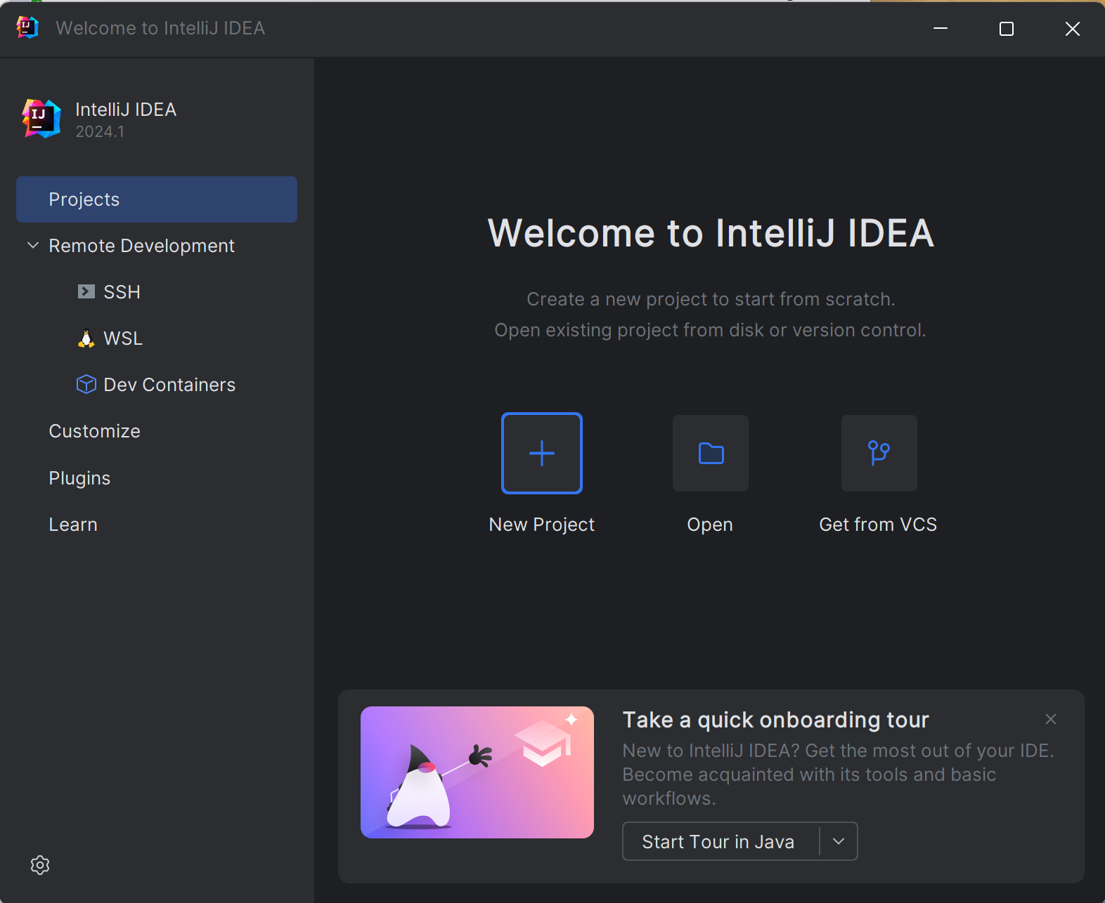

Step 2

Step 3

